Unit 8 – Lesson 1. Introduction to Virtual Reality

Aim: How do we create a simple VR cardboard Android app?
Objectives: After the lesson, students will be able to:
- Obtain basic understanding of GVR
- Set up a simple VR android app

CLASS PROCEDURE:
Do Now: Take out your phone, go to the App Store, look for ‘VR’, ‘Maze Walk’. Download the game to your phone. Take a pair of Google VR Glasses, and explore the game / app.

Questions:
- What is the difference between the VR maze game and a regular maze game?

- Why do we need to use the VR glasses?

Presentation / Class Discussion:
- What is the history of VR?
https://www.youtube.com/watch?v=hDWfsIbBtwE
We started from something like this image below….

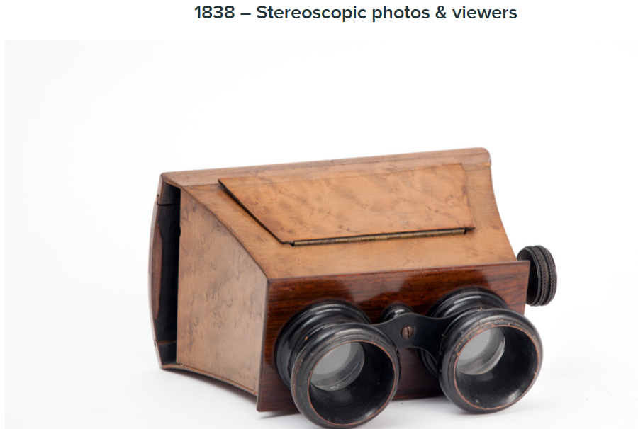

To something like this image now…

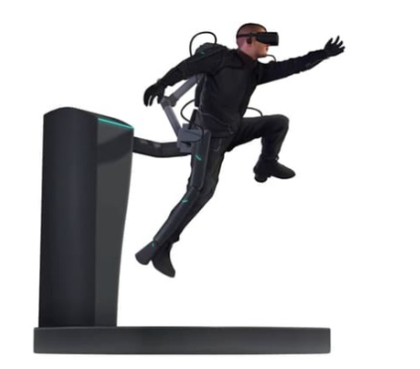
AR / VR Acquisition History in one diagram:

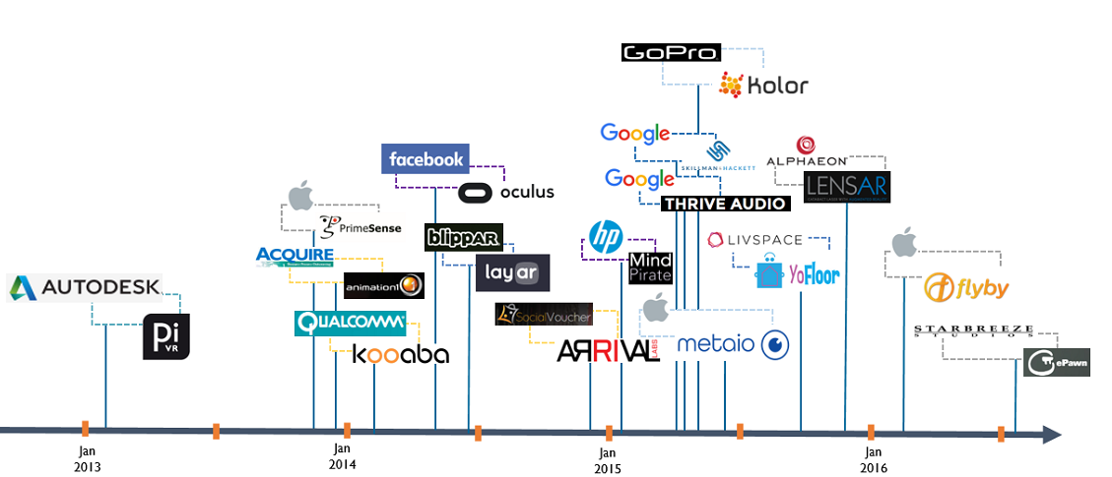

If you are interested, you can read more here: http://invisionstudio.com/the-history-of-vr-virtual-reality/

- What is are the differences between VR and AR?

- Augmented and virtual reality have one big thing in common. They both have the remarkable ability to alter our perception of the world. Where they differ, is the perception of our presence.

- Virtual reality is able to transpose the user. In other words, bring us someplace else. Through closed visors or goggles, VR blocks out the room and puts our presence elsewhere.

- Augmented reality however, takes our current reality and adds something to it. It does not move us elsewhere. It simply "augments" our current state of presence, often with clear visors. Seen below, Samsung is near ready to introduce its Monitor less AR glasses, which would connect to phones or PCs via WIFI and replace the screen on those devices.

- What are the differences between Day Dream and Google Cardboard VR apps?
  - Daydream is Android-only – starting with Android 7.0 Nougat. iOS devices will not be able to work with Daydream apps and VR headsets
  - There is a minimum reference standard for the Daydream VR headset – including motion sensors in the headset
  - The minimum standard for Daydream phones including processor, graphics co-processor, heat dissipation, RAM and display size and resolution. This will ensure that image quality, responsiveness and lag times are significantly better than existing Google Cardboard VR hardware.
  - Daydream defines a multi-button hand-held remote controller to let the user to interact with the VR world. The Daydream controller includes a clickable touchpad as well as 2 buttons called App and Home. This controller must be included with any Daydream-certified VR headset

- What are the different ways to create a VR app?

- GVR SDK for Android
- Unity
- Unreal

- In our class, we will use Unity to create VR apps. For this unit, you will create two VR projects. The first one is a navigation game with Bronx Science as the background. The second one is a jump jump game or motion game using VR.

Pair – sharing Activity:
- Go to Apple App Store or Google Play, download VR X – Racer to your phone. Explore the VR game.

- Search free VR game with 4 or 5 star rating at the app store, explore the VR apps or games.

